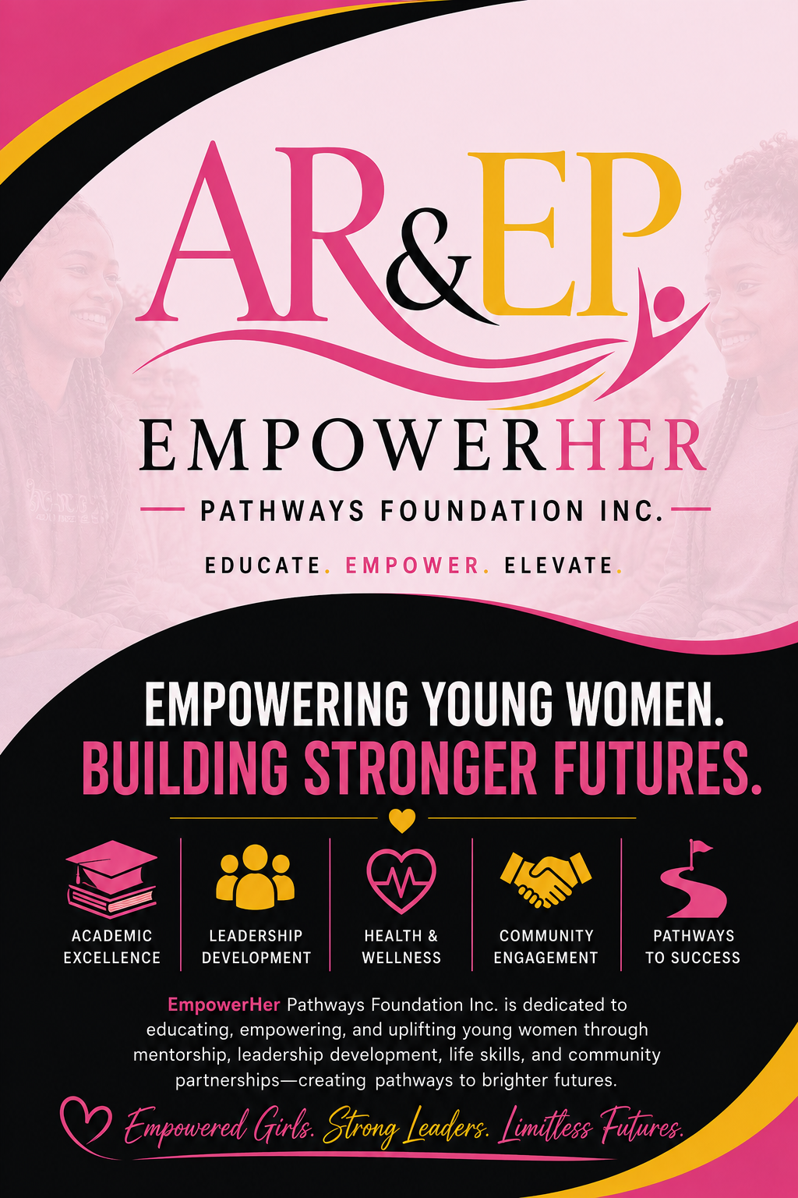
EmpowerHER Pathways Foundation Inc.
Community Partnership Packet
Building Leaders • Strengthening Communities • Creating Pathways to Success

Table of Contents
- Cover Letter
- About EmpowerHER Pathways Foundation Inc.
- Mission, Vision & Core Values
- Why Partner With Us?
- Our Signature Programs
- EmpowerHER Double Dutch Leadership Competition
- Pathways to Success Grant
- Community Partnership Opportunities
- Partnership Benefits
- Sponsorship Opportunities
- Community Partner Responsibilities
- Foundation Commitments
- Partnership Application
- Memorandum of Understanding (MOU)
- Contact Information

Welcome Letter
Dear Community Partner,
Thank you for your interest in partnering with EmpowerHER Pathways Foundation Inc.
We believe every young woman deserves access to leadership opportunities, positive mentorship, educational support, and experiences that prepare her for success beyond high school. Through our programs, participants develop confidence, discipline, teamwork, communication skills, and a commitment to serving their communities.
By partnering with us, your organization becomes part of a collaborative effort to create meaningful opportunities that inspire the next generation of leaders.
We look forward to building a lasting partnership that benefits both our youth and our community.
Sincerely,
Angelita Riviere
Founder & President
EmpowerHER Pathways Foundation Inc.

About EmpowerHER
EmpowerHER Pathways Foundation Inc. is a nonprofit organization dedicated to preparing young women for success through leadership development, mentorship, academic achievement, wellness, community engagement, and the sport of Double Dutch.
Our programs are designed to support and empower Black/African American young women and other historically underserved youth while remaining open to all eligible participants.

Mission
To equip young women with the leadership skills, confidence, educational resources, and community support needed to thrive academically, professionally, and personally.

Vision
To cultivate a generation of confident leaders who positively transform their schools, families, workplaces, and communities.

Core Values
- Leadership
- Integrity
- Respect
- Service
- Excellence
- Teamwork
- Accountability
- Community
- Empowerment
- Lifelong Learning

Signature Program
EmpowerHER Double Dutch Leadership Competition
Participants complete a year of leadership development, mentoring, community service, and academic growth before participating in the annual spring competition.
The program emphasizes:
- Leadership
- Academic success
- Community service
- Teamwork
- Sportsmanship
- Health and wellness
- Career readiness
- College preparation

Pathways to Success Grant
EmpowerHER Pathways Foundation Inc. recognizes outstanding achievements through the Pathways to Success Grant.
Grant Award
- $500 grant for each qualifying student
- Awarded to participants from the top two winning teams
- Up to 10 students per team
- Up to 20 grants awarded annually
- Up to $10,000 invested in students each year
Grant funds may be used for:
- College tuition
- Trade or technical education
- Certification programs
- Books and supplies
- Educational technology
- Workforce training
- Career preparation expenses
- Prom

Community Partnership Opportunities
Partners may support EmpowerHER through:
- Financial sponsorship
- Volunteer service
- Mentorship
- Career exploration
- Internship opportunities
- College readiness workshops
- Community service projects
- Event sponsorship
- Facility uses
- Transportation assistance
- Equipment donations
- Refreshments and meals
- Professional development

Partnership Benefits
Partners receive:
- Recognition on the EmpowerHER website
- Social media recognition
- Logo placement on selected event materials
- Recognition during community events
- Volunteer engagement opportunities
- Invitations to leadership events
- Networking with schools and community leaders
- Annual impact report highlighting program outcomes

Sponsorship Levels
Community Champion – $500
- Recognition as a Community Champion
- Logo on selected program materials
- Social media recognition
- Certificate of Appreciation
Bronze Partner – $1,000
Includes Community Champion benefits plus:
- Event banner recognition
- Recognition during one major event

Silver Partner – $2,500
Includes Bronze benefits plus:
- Featured logo placement
- Vendor table at one event
- Leadership program recognition
Gold Partner – $5,000
Includes Silver benefits plus:
- Sponsor spotlight throughout the program year
- Recognition at the annual awards ceremony
- Support of the Pathways to Success Grant initiative
Presenting Partner – $10,000+
Includes all previous benefits plus:
- Recognition as a Presenting Partner
- Opportunity to present grants during the awards ceremony
- Featured recognition on major program materials and annual reports

Community Partner Responsibilities
Partners agree to:
- Support positive youth development
- Maintain professionalism
- Foster a safe, respectful environment
- Comply with applicable laws and organizational policies
- Communicate openly with EmpowerHER staff

Foundation Commitments
EmpowerHER Pathways Foundation Inc. will:
- Provide quality leadership programming
- Maintain appropriate insurance coverage
- Screen volunteers and mentors as required
- Communicate regularly with partners
- Measure program outcomes
- Administer the Pathways to Success Grant fairly and transparently
- Recognizing partner contributions

Community Partnership Application
Organization Name: __________________________________
Primary Contact: _____________________________________
Title: ______________________________________________
Phone: _____________________________________________
Email: _____________________________________________
Address: ___________________________________________
We are interested in:
☐ Financial Sponsorship
☐ Volunteer Opportunities
☐ Mentorship
☐ Internship Opportunities
☐ Career Readiness Workshops
☐ College Readiness
☐ Community Service Projects
☐ In-Kind Donations
☐ Event Sponsorship
☐ Other: ______________________________
Authorized Representative
Name: _________________________________
Title: _________________________________
Signature: _____________________________
Date: _________________________________

Memorandum of Understanding (MOU)
This Memorandum of Understanding establishes a collaborative partnership between EmpowerHER Pathways Foundation Inc. and the participating organization to support youth leadership development and educational opportunities.
The parties agree to:
- Work collaboratively toward shared goals.
- Promote positive youth development.
- Maintain open communication.
- Respect participant confidentiality where applicable.
- Follow all applicable organizational policies.
- Review the partnership annually.
This MOU may be amended by mutual written agreement and may be terminated by either party with written notice.
Partner Representative
Name: ______________________
Signature: __________________
Date: _______________________
EmpowerHER Pathways Foundation Inc.
Representative: Angelita Riviere
Signature: __________________
Date: _______________________

Contact Information
EmpowerHER Pathways Foundation Inc.
Founder & President: Angelita Riviere
Email: empowerherpathwayfoundation@gmail.com
Phone: (954) 588-8462
Website: info@empowerherpathways.org
Together, we are creating pathways to leadership, education, and opportunities for the next generation.

